Job Description & Person Specification
Position: Head of Learning and Development
Reports To: Director of People and Culture
Levelling Framework: 2A
Salary Range: £58,000 to £65,000
Contract: Permanent
Hours Per week: 35

Our Values and Behaviours
To act in accordance with “Our Values and Behaviours” at all times when delivering your role, ensuring that “Kindness”, “Respect”, “Belonging”, and “Empowerment” are fundamental to your behaviour.
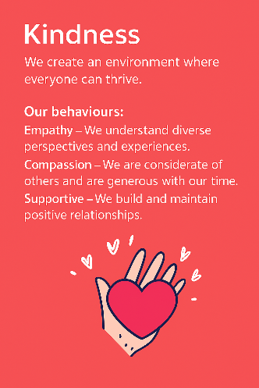
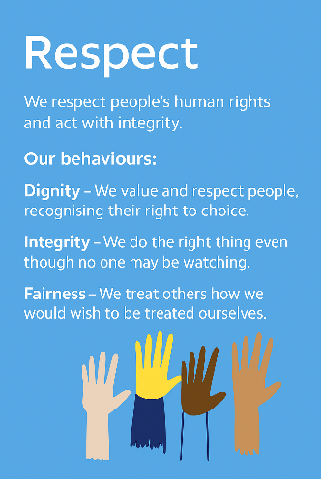
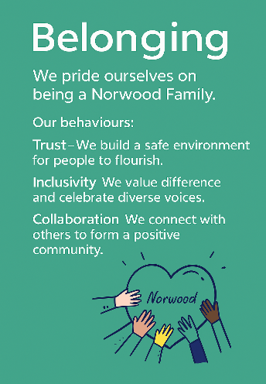
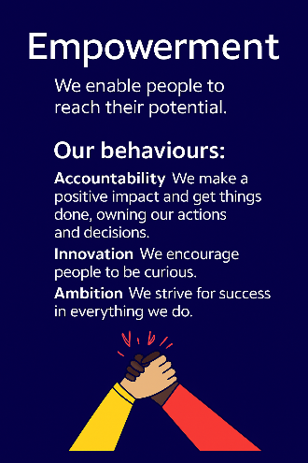
Empowerment
Respect
Belonging
Kindness

Policies and Procedures
In addition to undertaking the accountabilities as outlined below, the post holder will be expected to fully adhere to all Norwood policies and procedures which are referenced in the employment contract and Norwood's intranet.
Role Summary

The Head of L&D is responsible for contributing to the development and delivery of the People and Culture strategy and implementation plans. The post-holder takes overall responsibility for leading the design and delivery of learning and development activity for all Norwood employees and volunteers, ensuring they have the necessary skills to carry out their roles to a high quality, The Head of L&D has ultimate accountability for ensuring compliance with mandatory training standards, linked to CQC and other regulations. The post-holder supports the work of the Director of People & Culture in respect of EDI strategy, policy and practice as well as for assisting with organisational development initiatives.

Key Accountabilities

- Strategic Leadership & Collaboration

- Contribute to the development and delivery of the People & Culture strategy.
- Partner with operational leaders to design Norwood’s learning & development offer, undertake specific training analyses and ensure the function delivers in line with external regulatory requirements, including that of CQC for regulated roles.
- Act as the organisation’s subject matter expert on learning & development, providing cost-effective and innovative solutions.
- Monitor external developments in l&d to ensure Norwood delivers high quality learning opportunities
- Be responsible for the establishment of learning standards and processes
- Be responsible for the continuous improvement of the learner management system
- Support the Director of People & Culture with the development of organisation-wide EDI strategy, policy and practice, with a particular focus on the learning that arises
- Support the Director of People & Culture with organisational development programmes of work and initiatives, including culture change, structural change and ways of working

- Values, Culture & Compliance

- Embed equality, diversity, and inclusion principles across all learning and OD activity
- Champion person-centred and values-based learning aligned with Norwood’s culture
- Develop line managers and P&C staff to maintain consistent compliance and best practice in learning and development

- Service Delivery & Partnership

- Establish a clear framework for mandatory training and the provision of regular compliance reporting and follow up recommendations
- Build strong, customer-focused partnerships with the SLT and line managers to design appropriate learning options in respect of management development and leadership skills
- Be responsible for the design and delivery of effective induction processes
- Implement and monitor learning KPIs and performance measures, providing regular reports on outcomes
- Manage the learning & development budget, ensuring effective use of resources and value for money in training delivery
- Oversee provider relationships, ensuring contractual compliance, cost control, and quality service delivery

- Leadership & Team Development

- Lead and develop the L&D team to deliver a partnership model, ensuring consistent, high-quality learning services and continuous professional growth
- Build capability across the organisation by coaching managers in safer recruitment and inclusive selection practices
- Promote collaboration and continuous improvement within the People & Culture function
- Undertake other duties aligned with the post to support departmental and organisational objectives

This job description is not exhaustive and may be updated as accountabilities evolve.

Person Specification

 | Essential | Desirable | Evidence
Qualification(s) | Member of the CIPD or equivalent People and Culture/L&D experience |  | Cover Letter / CV / Onboarding
Experience | 1.Experience of leading an L&D function within a fast-paced service-focused organisation  2.Experience of undertaking organisational training needs analyses  3.Experience of commissioning training and learning programmes and managing external providers  4.Experience of designing and implementing induction processes  5.Experience of designing and implementing management development and leadership programmes | - Experience in health or social care  - Experience of the design service user involvement in training  - Experience of organisational development work in a complex organisation  - Experience of development EDI strategies | CV / Interview / Onboarding
Knowledge, Skills & Abilities | - Extensive knowledge of how organisations ensure continuous learning and development  - Knowledge of learning methodology and best practice in leadership development  - Knowledge of equalities legislation and best practice in employment  - Commercial acumen  - Emotional intelligence and strong communication | - Knowledge of the requirements of CQC in respect of l&d in the care sector  - Understanding of values-based learning and service user involvement in learning | Cover Letter / CV / Interview
Personal Qualities & Attributes | - Flexibility to travel (London & Berkshire)  - Commitment to Norwood’s values: Kindness, Respect, Belonging, Empowerment  - Adaptable, proactive, and self-sufficient  - Credible communicator with all levels  - Highly customer-focused |  | Cover Letter / CV / Interview

All roles require a DBS check and satisfactory clearance under Norwood’s safer recruitment policies. We are committed to safeguarding the wellbeing of our people and maintaining a respectful, safe environment.

