Job Description & Person Specification
Position: People Co-ordinator (Recruitment)
Reports To: Head of Recruitment
Levelling Framework: 6A
Salary Range: £23,497 to £26,108
Contract: Permanent
Hours Per week: 24

Our Values and Behaviours
To act in accordance with “Our Values and Behaviours” at all times when delivering your role, ensuring that “Kindness”, “Respect”, “Belonging”, and “Empowerment” are fundamental to your behaviour.
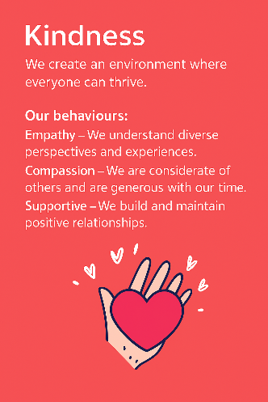
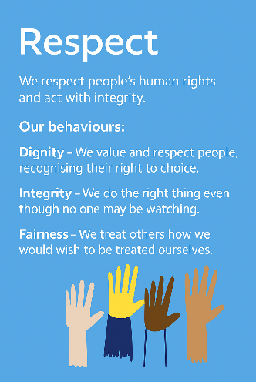
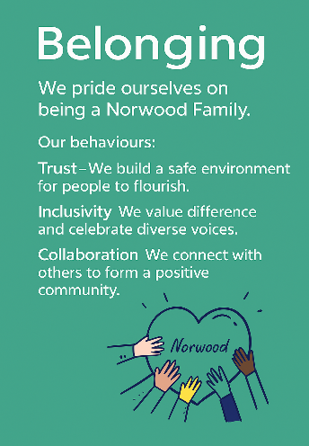
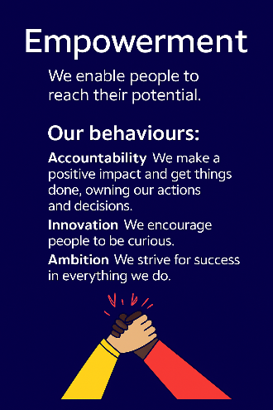
Empowerment
Respect
Belonging
Kindness

Policies and Procedures
In addition to undertaking the accountabilities as outlined below, the post holder will be expected to fully adhere to all Norwood policies and procedures which are referenced in the employment contract and Norwood's intranet.
Role Summary
The purpose of this role is to co-ordinate recruitment processes and to undertake administrative responsibilities relating to the on-boarding and vetting of new staff. Whilst the main focus of the role will be in the recruitment service, the post-holder will be required to deliver administrative services to support the L&D team, the People Partnering Team and the People Culture team as a whole.

Key Accountabilities: Recruitment
- Carry out all tasks associated with the on-boarding of new staff at Norwood.
- Draft offer letters and contracts of employment.
- Undertake pre-employment checks and vetting in line with agreed standards (Right To Work, DBS, references etc).
- Maintain records on the Applicant Tracking System and HR Database of pre-employment check activities and information.
- Produce reports from the systems about recruitment activity and compliance with on-boarding standards.
- Liaise closely with hiring managers about arrangements for new starters.
- Liaise with the L&D team about arrangements for induction and mandatory training for new starters.
- Assist the Head of Recruitment and Recruiters in organising advertising and other applicant attraction methods.
Key Accountabilities: Other
- Process new starters, leavers and changes to employee conditions (e.g. change of hours, job title, salary etc).
- Maintain the L&D calendar and organise staff to attend classroom learning and to undertake e-learning.
- Schedule training sessions and maintain records of attendance.
- Support the L&D team with the administrative tasks associated with the employment of apprentices and the obtaining of qualifications.
- Generate reports from the systems as required (e.g. sickness incidences, probation status, mandatory training compliance etc).
- Respond to requests from managers and staff (e.g. employment confirmation).
- Attend meetings and take notes.
- Provide administrative assistance to the People Partnering and L&D teams and to the P&C team as a whole (e.g. organising team meetings).
- Provide administrative and support to the P&C team (e.g. organising team and other meetings and providing diary support to senior P&C leaders|)
This job description is not exhaustive and may be updated as accountabilities evolve.
Person Specification
 | Essential | Desirable | Evidence
Qualification(s) | GCSEs in Maths and English or equivalent | A Levels or HNC | Cover Letter / CV / Onboarding
Experience | - Administrative experience in a busy, customer-focused environment  - Confident use of databases and software systems | - HR or recruitment administration experience  - Producing reports from databases | CV / Interview / Onboarding
Knowledge, Skills & Abilities | - Strong organisational skills and attention to detail  - Proficiency with IT and digital systems  - Clear and confident communication skills  - Commitment to excellent customer service | - Awareness of recruitment and onboarding processes including relevant regulatory and compliance requirements (CQC/ Ofsted/Right to Work/and so on) | Cover Letter / CV / Interview
Personal Qualities & Attributes | - Flexible to travel between Norwood sites (London & Berkshire)  - Adaptable, proactive, and values-led  - Demonstrates Norwood’s values of Kindness, Respect, Belonging, and Empowerment | - | Cover Letter / CV / Interview
All roles require a DBS check and satisfactory clearance under Norwood’s safer recruitment policies. We are committed to safeguarding the wellbeing of our people and maintaining a respectful, safe environment.

